***Section* 4.3 – Polar Coordinates and Graphs**

***Definition* of Polar Coordinates**

To define polar coordinates, let an ***origin*** *O* (called the ***pole***) and an ***initial ray*** from *O*. Then each point *P* can be located by assigning to it a ***polar coordinate pair***  in which r gives the directed from *O* to *P* and *θ* gives the directed angle from the initial ray to yay *OP*.

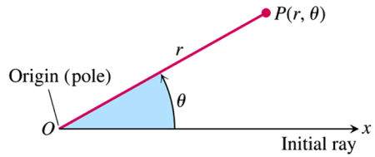

***Polar Coordinates***

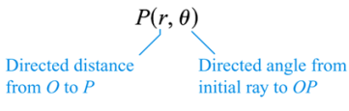

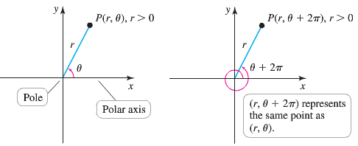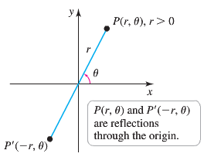 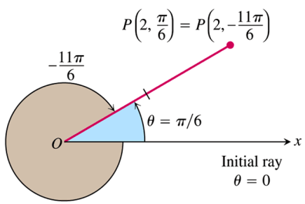

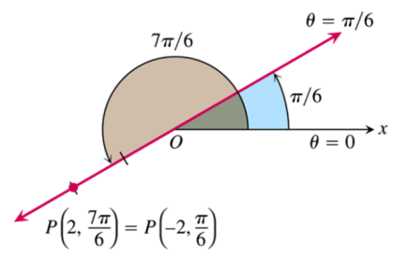***Example***

Find all the polar coordinates of the point 

***Solution***

For 

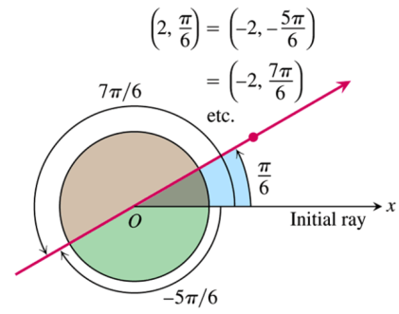For 

The corresponding coordinate pairs of *P* are



And



**Polar Equations and Graphs**

|  |  |
| --- | --- |
| ***Equation*** | ***Graph*** |
|  | Circle of radius  centered at *O* |
|  | Line through *O* making an angle  with the initial ray |

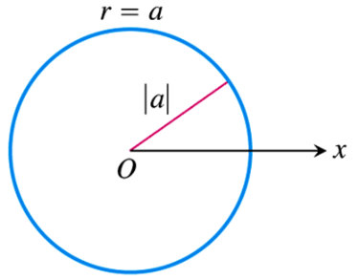

***Example***

Graph the polar coordinate 

***Solution***

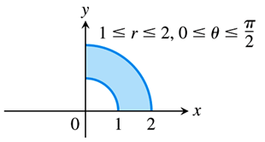

***Example***

Graph the polar coordinate 

***Solution***

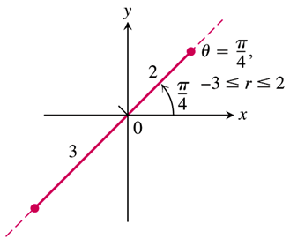

***Example***

Graph the polar coordinate 

***Solution***

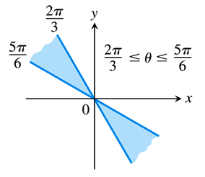

**Relating Polar and Cartesian Coordinates**

When we use both polar and Cartesian coordinates in a plane, we place the two origins together and take the initial polar ray as the positive *x-*axis. The ray  becomes the positive *y-*axis. The two coordinate systems are then related by the following equations

***Equations Relating Polar and Cartesian Coordinates***



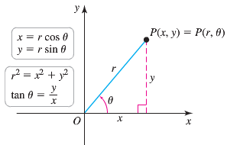

|  |  |
| --- | --- |
| ***Polar equation*** | ***Cartesian equation*** |
|  |  |
|  |  |
|  |  |
|  |  |
|  |  |

**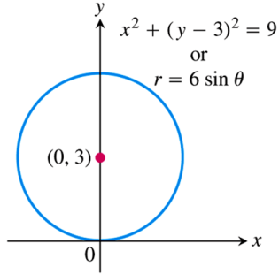*Example***

Find a polar equation for the circle 

***Solution***





 







***Example***

Replace the polar equation by equivalent Cartesian equation and identify the graph: 

***Solution***



The graph: Vertical line through 

***Example***

Replace the polar equation by equivalent Cartesian equation and identify the graph: 

***Solution***









 The ***graph***: Circle with center (2, 0) and radius 2.

***Symmetry* Test for Polar Graphs**

1. ***Symmetry about the x-axis***: If the point  lies on the graph, then the point  or  lies on the graph.

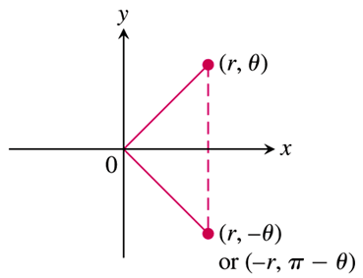

1. ***Symmetry about the y-axis***: If the point  lies on the graph, then the point  or  lies on the graph.

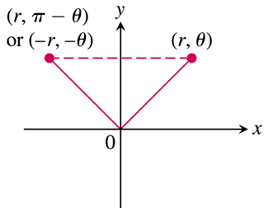

1. ***Symmetry about the origin***: If the point  lies on the graph, then the point  or  lies on the graph.

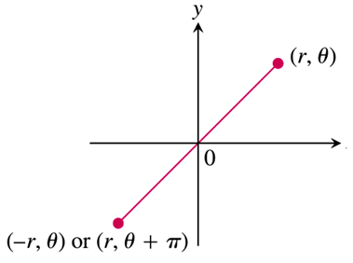

***Example***

Graph the curve 

***Solution***

The curve is symmetric about the *x*-axis:



|  |  |
| --- | --- |
| *θ* |  |
| 0 | 0 |
|  |  |
|  | 1 |
|  |  |
|  | 2 |

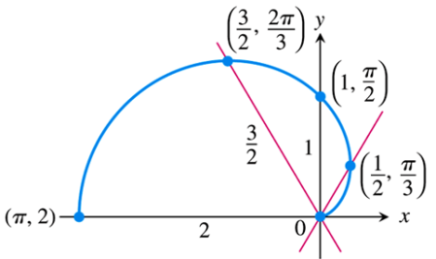

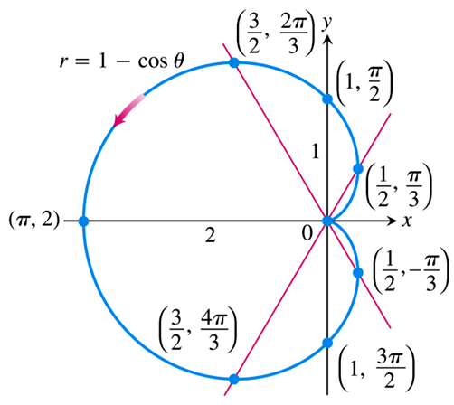

***Example***

Graph the curve 

***Solution***

The curve is symmetric about the *x*-axis:







The curve is symmetric about the *origin*:







Therefore, the curve is also symmetric about the *y*-axis.





|  |  |  |  |  |  |  |  |  |  |  |  |  |  |
| --- | --- | --- | --- | --- | --- | --- | --- | --- | --- | --- | --- | --- | --- |
| |  |  | | --- | --- | | *θ* |  | | 0 |  | |  |  | |  |  | |  |  | |  | 0 | |  |

***A Technique for Graphing***

One way to graph a polar equation  is to make a table of  values, plot the corresponding points, and connect them in order of increasing.

Another method of graphing more reliable is

1. First graph  in the *Cartesian* ,
2. Then use the *Cartesian* graph as a table and guide to sketch the *polar coordinate* graph.

***Example***

Graph the *lemniscate* curve 

***Solution***

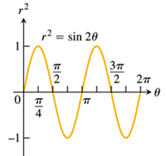 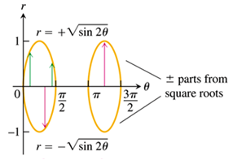

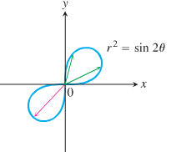

|  |  |  |  |  |  |  |  |
| --- | --- | --- | --- | --- | --- | --- | --- |
|  | 0 |  |  |  |  |  |  |
|  | 0 |  |  |  | 0 | 0 |  |

***Exercises Section* 4.3 – Polar Coordinates**

1. Find the Cartesian coordinates of the following points (given in polar coordinates)



1. Find the polar coordinates, , of the following points given in Cartesian coordinates



1. Find the polar coordinates, , of the following points given in Cartesian coordinates



(**4 − 8**) Graph

|  |  |
| --- | --- |
|  |  |

(**9 − 20**) Replace the polar equation with equivalent Cartesian equation and identify the graph

|  |  |  |
| --- | --- | --- |
|  |  |  |

(**21 − 27**) Replace the Cartesian equation with equivalent polar equation

|  |  |  |
| --- | --- | --- |
|  |  |  |

1. ***a*)** Show that every vertical line in the *xy*−plane has a polar equation of the form 

***b*)** Find the analogous polar equation for horizontal lines in the *xy*−plane.

(**29 − 34**) Identify the symmetries of the curves. Then sketch the curves.

|  |  |  |
| --- | --- | --- |
|  |  |  |

(**35 − 37**) Graph the lemniscate. What symmetries do these curves have?

|  |  |  |
| --- | --- | --- |
|  |  |  |

(**38 − 42**) Graph the limaçons is Old French for “snail”. Equations for limaçons have the form 

|  |  |  |
| --- | --- | --- |
|  |  |  |

(**43 − 46**) Graph the equation

|  |  |  |  |
| --- | --- | --- | --- |
|  |  |  |  |

1. Graph the ***nephroid*** of ***Freeth*** equation 
2. Water flows in a shallow semicircular channel with inner and outer radii of 1 *m* and 2 *m*. At a point  in the channel, the flow is in the tangential direction (counterclockwise along circles), and it depends only on *r*, the distance from the center of the semicircles.

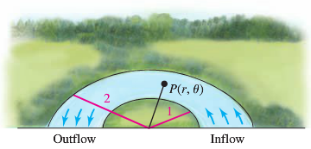

1. Express the region formed by the channel as a set in polar coordinates.
2. Express the inflow and outflow regions of the channel as sets in polar coordinates.
3. Suppose the tangential velocity of the water in *m/s* is given by , for . Is the velocity greater at  or ? Explain.
4. Suppose the tangential velocity of the water is given by , for . Is the velocity greater  or ? Explain.
5. The total amount of water that flows through the channel (across a cross section of the channel ) is proportional to . Is the total flow through the channel greater for the flow in part (*c*) or (*d*)?
6. A simplified model assumes that the orbits of Earth and Mars are circular with radii of 2 and 3, respectively, and that Earth completes one orbit in one year while Mars takes two years. When . Earth is at  and Mars is at ; both orbit the Sum (at ) in the counterclockwise direction.

The position of Mars relative to Earth is given by the parametric equations



1. Graph the parametric equations, for 
2. Letting , explain why the path of Mars relative to Earth is a limaçon.